# Table of Contents

Table of Contents 1

Introduction 2

• Purpose of the guide 2

• Importance of Women's Safety 2

Understanding GPS Tracking Devices 3

• What is Women’s Safety GPS Tracking Device 3

Hard ware components 4

• Functions of the components 4

Diagram Of This Project 6

• Real-Time Location Monitoring 6

• Emergency Response Capabilities 6

• Peace Of Mind 6

• Stop The Crime 7

# Introduction

## Purpose of the guide

• **Empowerment**: It empowers women by providing them with knowledge about technological tools that can potentially increase their personal safety and security, especially in situations where they may feel vulnerable.

• **Safety Awareness**: It raises awareness about the importance of proactive safety measures and how GPS tracking devices can play a role in enhancing personal security, whether in everyday life, during travel, or in emergency situations.

• **Decision Making**: It helps women and their support networks (family, friends, caregivers) make informed decisions when choosing a GPS tracking device, considering factors such as features, usability, privacy concerns, and legal implications.

* **Usage Advice**: It provides helpful advice on how to utilize GPS tracking devices in an efficient manner, covering setup, upkeep, and recommended practices to guarantee maximum performance and dependability.
* **Privacy and Ethical Issues** It promotes responsible usage and respect for individual rights by addressing privacy issues and ethical issues related to the use of GPS tracking technology.

## • Importance of Women's Safety

* **Human Rights:** Preserving women's safety complies with their fundamental right to be free from discrimination, abuse, and harassment.
* **Health and Well-Being**: Women's physical, mental, and emotional well-being are influenced by their sense of safety, which enhances their general health and quality of life.

**Empowerment:** Women who are safe can engage fully in society, pursue their studies and occupations, and engage in social activities without worrying about being harmed or intimidated.

* Violence Prevention: Safeguarding women's safety helps to prevent violence against them by encouraging amicable and courteous relationships.

# Understanding GPS Tracking Devices

## What is Women’s Safety GPS Tracking Device

* The security of women A GPS tracking device is a specific tool meant to improve women's personal security and safety. Usually, it combines GPS (Global Positioning System) technology with other features to offer emergency response and real-time position tracking. These discrete, wearable, and small gadgets are made to be carried or worn by people with ease.  
    
  Women's safety GPS tracking devices may have the following important features:  
    
  Real-time location monitoring: Usually via a mobile app or online platform, this feature enables users (or certain contacts) to precisely follow their location via GPS.  
    
  SOS/Emergency Button: A special button that, when touched, notifies emergency services or pre-defined contacts of the user's position and transmits an instant distress signal.  
    
  Geo-Fencing: Creating virtual walls or secure areas and setting up alarms to sound when

How GPS Tracking Device Works

* GPS technology is the device's main component; it uses satellite communication to pinpoint the exact location of the object on Earth. Accurate position information and device tracking depend on this location data.
* Communication: To send position data to a specified monitoring center, a smartphone app, or directly to predefined contacts, a lot of GPS tracking devices use cellular or satellite communication technologies.  
    
  Emergency/SOS Button: The majority of devices come with an emergency feature or SOS button. This button, when touched, instantly sends the current GPS coordinates and a distress signal to pre-identified contacts (such friends, family, or emergency serices).

# Hard ware components

## Functions of the components

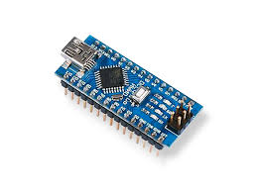

**Arduino Nano**

Arduino Nano is used in robotics for controlling motors, sensors, and actuators in robots and robotic arms & function the codes

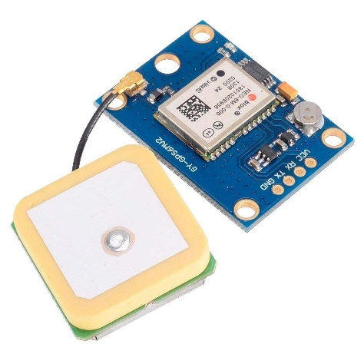

**GPS Module**

The GPS module receives signals broadcast by GPS satellites. These signals contain timing information and data about the satellite's position in space

It’s Used to Send locations to Parents/Guardians

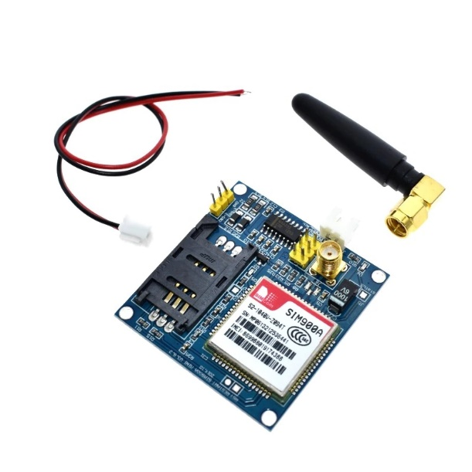**GSM Module**

It is responsible for establishing and maintaining the communication link between the device and the network.

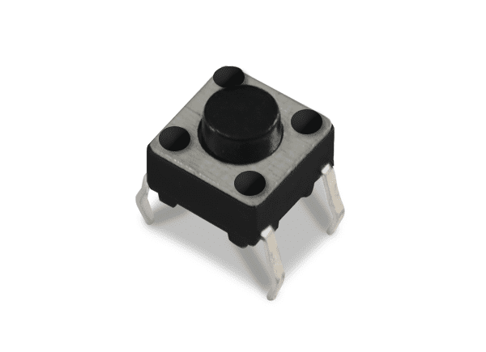**One Push Button**

They are capable of controlling a wide range of electronic gadgets

**Buzzer**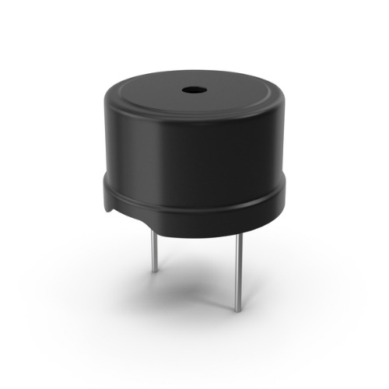

Its primary function is to provide an audible alert or notification and typically operates within a voltage range of 5V to 12V.

# Diagram Of This Project

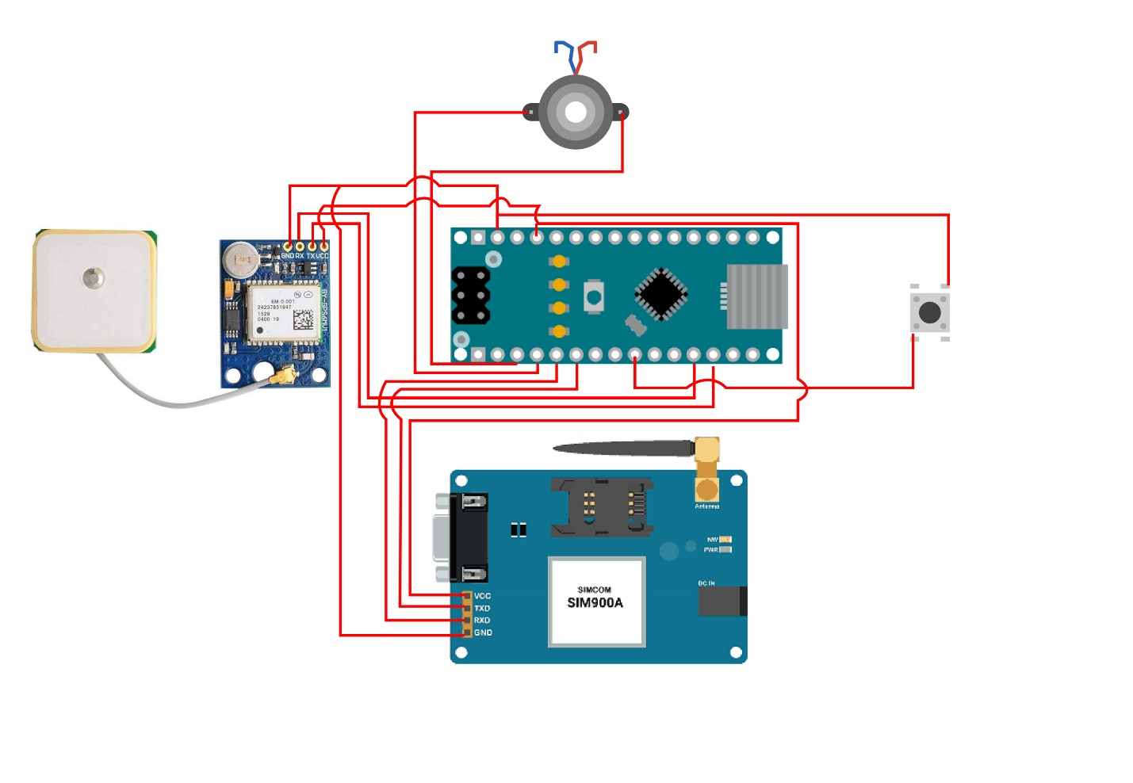Benefits of Women's Safety GPS Tracking Devices

## Real-Time Location Monitoring

GPS tracking devices allow users and their trusted contacts to monitor their location in real-time. This feature is invaluable for tracking movements during travel, outdoor activities, or when navigating unfamiliar or potentially risky environments.

## Emergency Response Capabilities

With GPS tracking devices, users can follow their whereabouts in real time and share that information with trusted contacts. This capability comes in quite handy for tracking movements when traveling, engaging in outdoor activities, or traversing uncharted or potentially dangerous areas.

## Peace Of Mind

Knowing that a GPS tracking device is available can provide reassurance to users and their loved ones. It offers a sense of security, especially when traveling alone or in situations where personal safety may be a concern.

## Stop The Crime

The presence of a visible GPS tracking device can act as a deterrent against potential threats or attackers, as it indicates that help can be summoned quickly in case of emergency.